
July 2010 Volume IV, No. 3
Among Friends

Money Makes the World Go ‘Round  So donate if you can.  The Friends of the Library have spent close  to $12,000 so far this year on books and  A/V items, shelving, Summer Reading  Program supplies, refreshments, printers, newsletters, the children’s Chess Club –  even water for the Wise Walk program.  Your contributions support all of this. You  can help in many ways:  ٠ Renew your Friends membership at a  higher level. One lovely Friend renews  every time he gets a newsletter; he’s  paid up through 2015!  ٠ Tell us to “keep the change” when you  buy used books.  ٠ Send us a check in honor of someone  special; a note will go to the honoree if  you provide the info. | The weather is lovely and we have reached another summer with its relaxing days and nights. The library has enough money to last through December 2010 and we can pat ourselves on the back for all that we have done to make this possible.  However, 2011 will come soon and we must prepare for yet another battle in the war to keep these libraries open. Please continue to call and to write to your city and state elected officials concerning the importance of our libraries. Only with your help as individuals can we hope to make the coming years viable.  Thank you for all you have done and will do to keep our libraries open.
  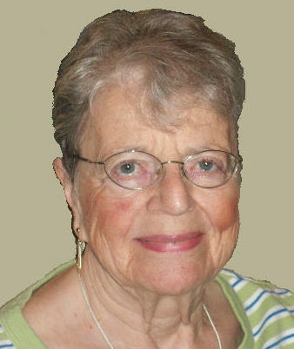 | PRESIDENT’S MESSAGE  by Joan Schwartzman  That beautiful season… Summer….  Filled was the air with a dreamy and magical light; and  the landscape  Lay as if new created in all the freshness of childhood.  --Henry Wadsworth Longfellow 1807-1882

 | The state  budget is due  by June 30.  Take action  NOW to  increase library  funding. | Random thoughts:  hope this gets to readers in time. But if state gov’t runs true to form, the budget will still be being debated in July…….. readers should also urge legislators to restore the budget for the statewide databases that have been lost..….go to www.carnegielibrary.org/about/future/ppyl/  for links to complete info, addresses, etc.  Pittsburgh now recycles hardcover books. If your books are too old/decrepit for us, blue bag them and put them at the curb on recycling day.

WELCOME, NEW MEMBERS | Join us at our regular  Friends Meetings:    Saturday Sept 11 at 10 a.m.  Saturday Oct 2 at 10 a.m. | A pessimist sees only the dark side of the clouds, and mopes;  A philosopher sees both sides, and shrugs;  An optimist doesn’t see the clouds at all -- he’s walking on them.  Leonard Louis Levinson  1904-1974
  Preston | Allen |  | Ben | King
  Joan  Nancy | Bloch  Brent |  | Richard  Mildred | Lechner  Markowitz
  Barbara | Bridge |  | Mary | Miller
  Susan | Fedak |  | Lynn | Mossburg
  Dea | Fern |  | Sharon | Mycoff
  Mary | Hart |  | Marian & Jon | Salamon
  Joey | Haskins |  | Sandra | Seip
  Ian | Heiss |  | Helena | Taube
  Arlene | Hofbauer |  | Angela | Tuminello
  Sagav  James | Joshi  Kiley |  | Computing | Workshop
Published by the Friends of the Squirrel Hill Library, 5801 Forbes Avenue, Pittsburgh, PA 15217
website: www.carnegielibrary.org/locations/squirrelhill e-mail: friends@pittsburghusedbooks.com
editor: Joan Schwartzman production: Dean Damick, Marion Damick, Margie Spenser,
mailing list: Margie Spenser Serena Spenser, Leigh Anne Vrabel

July 2010 Among Friends Volume IV, No. 3

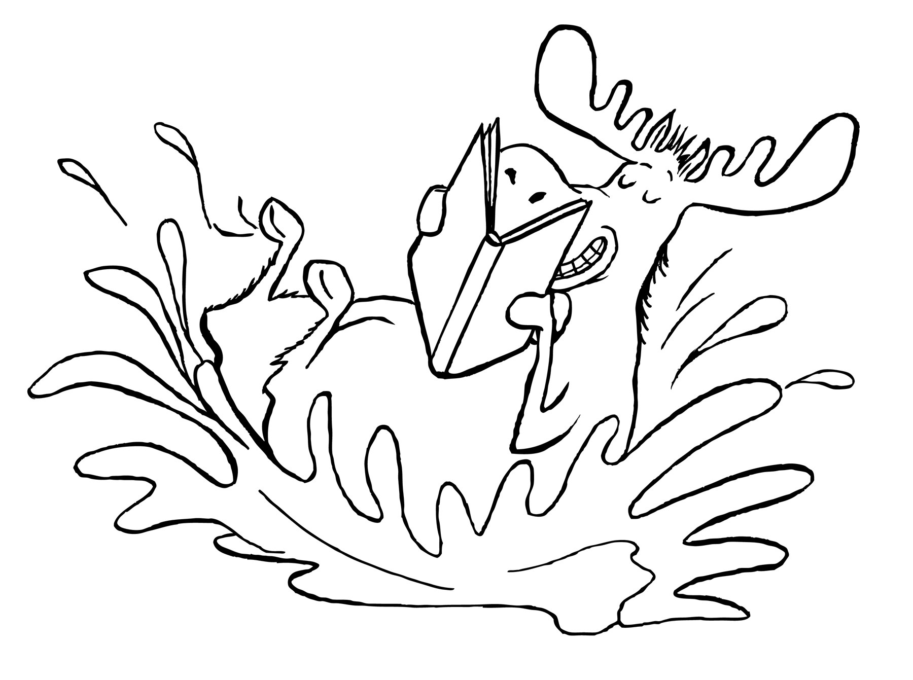 | Children’s Department Summer Happenings  by Megan Fogt  Manager of Children's Services  We’re MAKING A SPLASH @ THE LIBRARY with our Summer Reading Club for children up to age 12! SWIM into the library or SURF online at www.carnegielibrary.org/summer and sign up your child for Summer Reading Club! |  | 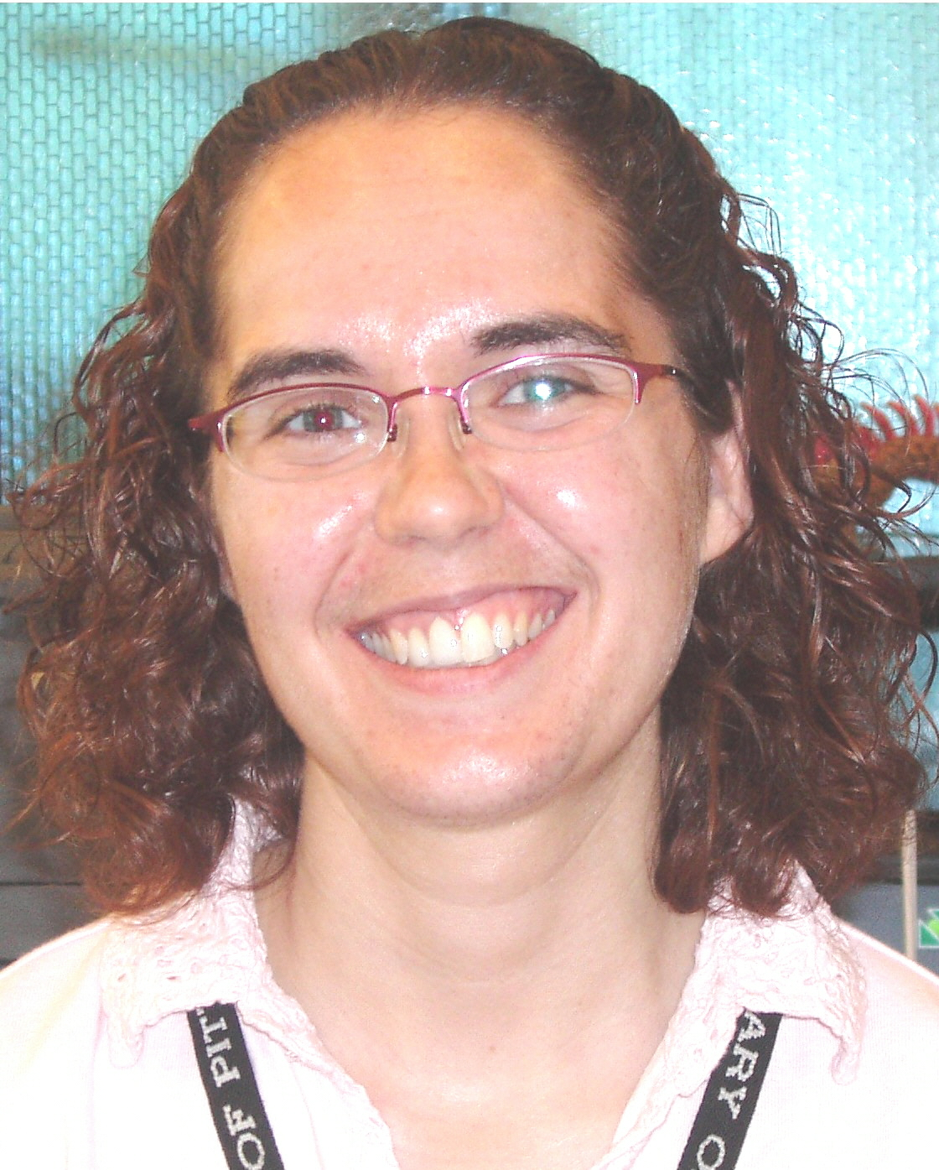
- Our Read-to-Me program is for young children who have books read to them. Celebrate the fun of reading to your child, while providing them with the early literacy skills that research suggests all children need to learn to become strong readers.

- Our Readers program is for children reading on their own. Research suggests that students who read at least six books over the summer maintain their reading skills, while reading more than six books leads to gains in reading skills.
- Both our Read-to-Me and Reader programs feature a reusable book tote for signing up,
a free book for reading 5 books and a fabulous additional prize for reading 10 books!
Join the WAVES of people coming to the library for these activities and storytimes!
Go to www.carnegielibrary.org/kids/events for more information and news of other fun events!

- Family Storytime (all ages welcome) Mondays at 6:00 PM & Saturdays at 11:00 AM
- Terrific Tales for Toddlers (18 mo. – 3 yrs old) Tuesdays at 10:30 AM and 11:30 AM
- Baby & Me (birth – 18 mo.) Thursdays at 10:30 AM and 11:30 AM
- School-age Programs (for ages 5 – 12) Please register by calling 412-422-9841.
- Diary of a Wimpy Kid – Wed., July 7th at 3 PM Calling all WIMPY kids! Join us for wimpy games, wimpy crafts, and other wimpy fun!
- Rachel Carson Puppet Show – Wed., July 21st at 3 PM Explore the life of environmentalist Rachel Carson, told
through the dramatic medium of puppets!
- Papermaking – Wed., August 4th at 3 PM Make your own paper with recycled materials!
- Tie Dye Party – Wed., August 18th at 3 PM Bring a t-shirt (100% cotton) and your artistic talent and
we’ll provide everything else you need for some tie dying fun!
- Summer Reading Club Finale Monday, August 2nd at 6 PM
Everyone Loves Puppets will present a special Puppet show, “Wild and Wonderful Water!”.

Our new trains are chugga-chugga, choo-chooing down a new train layout thanks to the Friends of the Squirrel Hill Library! We recently purchased new pieces for our train table and a group of us put together the new layout with the help of a local 6 year old, Jonah Keller, who is a train table expert (and the son of one of our children's librarians). It's wonderful to have a train table that has all of its pieces again! On behalf of our children's staff and the many children that come into the library, I would like to thank the Friends of the Squirrel Hill Library for their donation.  Any book that helps a child to form a habit of reading, to make reading one of his deep and continuing needs, is good for him. Maya Angelou 1928- |  | 

2 2

2
July 2010 Among Friends Volume IV, No. 3
  Mark Russell,  Librarian |   Film,  Fiction,  and Fun | third Thursday of the month from 1 to 4  July 15  King Lear by William Shakespeare  filmed as Ran by Akira Kurosawa  August 19  A Thousand Acres by Jane Smiley  September 16  Raise the Red Lantern by Su Tong |   Jeanne Bergad, Moderator

Film, Fiction, and Fun is a special series presented at the Carnegie Library of Pittsburgh -- Squirrel Hill that explores the relationship between films and the novels that inspired them. Attendees are encouraged to read a monthly fiction selection, then join CCAC’s Jeanne Bergad for a screening of the film and discussion to follow.  July 15th’s title is King Lear, by William Shakespeare. Believed to have been written sometime between 1603 and 1606, Shakespeare’s famous play chronicles the tragic fall and descent into madness of the titular king, who foolishly allows flattery to determine how he will divide his kingdom among his three daughters. Akira Kurosawa’s film Ran, set in Sengoku-era Japan, is based on the story of Lear, as well as the legends of warlord Mori Motonari. Kurosawa’s Lear figure, Hidetora, also banishes his only loyal offspring, in this case his youngest son Saburo, and as in Lear, this is the beginning of a chain of tragic events. At the time of its production (1985), Ran was the most expensive Japanese film ever made, at a budget of $12 million.  August 19th’s novel is A Thousand Acres, by Jane Smiley. Published in 1991, Smiley’s Pulitzer Prize-winning novel is a retelling of the story of King Lear, set on an Iowa farm. The patriarch of the story, farmer Larry Cook, decides to incorporate his farm with his three daughters as equal shareholders. When the objections of the youngest daughter, Caroline, cause her to be cut out of the deal, dark events from the past rise to the surface, with tragic consequences for the Cooks and their friends and neighbors. The 1997 film starred Jessica Lange, Michelle Pfeiffer, and Jennifer Jason Leigh as daughters Ginny, Rose, and Caroline, and Jason Robards as their father, Larry. For her performance, Lange was nominated for a Golden Globe.  September 16th’s title is Raise the Red Lantern by Su Tong. Originally titled Wives and Concubines, this novel is set in 1930’s China, and tells the story of Lotus, a young college student who becomes a concubine in the wealthy Chen household after her father’s business goes bankrupt and he commits suicide. Lotus finds herself in competition with three other concubines, and she becomes immersed in household intrigues. The 1991 film, starring Li Gong, was nominated for the Academy Award for best foreign film. Although it did not win the Oscar, it picked up best foreign film awards from many other organizations, including the New York, Los Angeles, and London film critics circles.  We held an Impromptu Book Sale in late May when we were offered the books left over from a sale at the Community Day School on Beechwood Boulevard. With no space to store the books, we put them out for sale as soon as we got them here. Despite the lack of publicity, we made more than $650! Then, all of our leftovers went to Knoxville Branch for their book sale, which made $###! Thanks to Community Day for the very high quality donation, and for a great deal of help loading it up.  3 | This is not a novel to be tossed aside lightly.  It should be  thrown with great force.  Dorothy Parker  1893-1967
 | 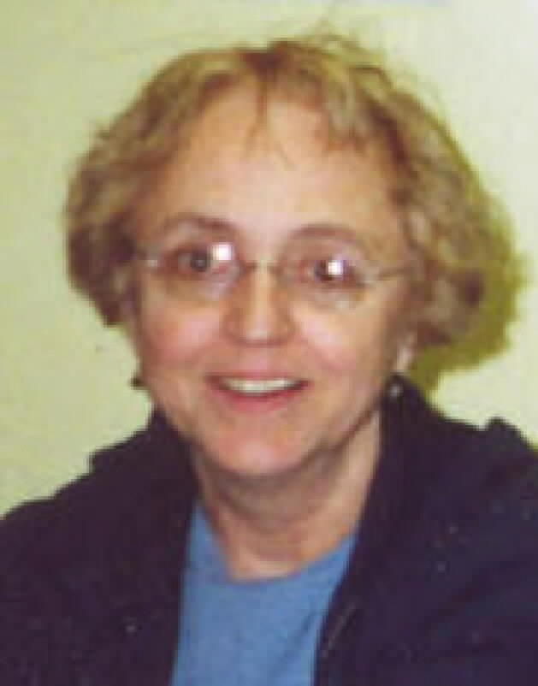 | MINI SALE NEWS  by Pat Bender,  mini-sale chair
The July Sidewalk Sale is our next big thing. It's been a while since we've had a boutique and this one will be special, with many new things among our adult and kids' jewelry and knitted items. We have some turquoise, coral, mother of pearl and a selection of exciting vintage pieces as well as watches. There are fun knitted baby hats and summer scarves and shawls for adults plus a group of handbags knitted with "plarn." Some items from previous sales will be sold at reduced prices.
We are still in desperate need of help in the book room. Boxes of books are donated almost daily. I will gladly get any volunteer started in sorting and shelving or boxing for
sales. I promise to be gentle.
Contact me, please, at oursounds@msn.com so we can set up a training session.
The Judaica and general religion and philosophy sale will be held in September. We will have a boutique and flea market at that
sale.

..
July 2010 Among Friends Volume IV, No. 3

July 2010 Among Friends Volume IV, No. 3
BOOKS, BOOKS, BOOKS, BOOKS, BOOKS, BOOKS, BOOKS,BOOKS  SPRING CLEANUP SALE: We earned more than $2,000 for the library at our sale at the end of April. Once again, young adults from the Job Corps volunteered to do the heavy lifting, along with John Henry Harrison, Bill Jones, and Bob Shapiro. We keep hoping some younger folks will join the Friends and take on some of the work. Start a family tradition! Mature teenagers, too, would be welcome. Let us know you’re interested and we’ll add you to the lists Anita Newell uses when she is calling for volunteers for a specific sale. She also will be looking for people to cashier and tidy up. |   by Margie Spenser  Book Sale Committee
SUMMER SALE: We will be selling all of our fiction, foreign language, children’s books, and audio-visual items (tapes & disks) at the Summer Fiction Sale on July 15-18, during the Squirrel Hill Sidewalk Sale. We sure could use some more foreign language books – they are so popular and we get so few.

HEY, YOU OUT THERE --
wir benötigen Bücher auf Deutsch, necesitamos los libros en español, мы книги на русском языке, nous avons besoin de livres en français, χρειαζόμαστε τα βιβλία στα ελληνικά ,abbiamos bisogno dei libri in italiano and nós necessitamos livros no português. Not to mention our need for and
 | and | .
AND we need paperback mysteries (we never have enough of those) in English, and children’s picture books, and VOLUNTEERS… and time... energy…sanity

Here we go again – at our Impromptu Book Sale, somebody picked up 3 books from the Cashier’s table that were not theirs. We especially need the LIBRARY BOOK back – one of J. D. Robb’s futuristic mysteries – Kindred in Death.

 | NAMM BUSINESS CENTER PROGRAMS    July -- September 2010  by Dorothy Kabakeris, Namm Business Center Librarian  All programs are scheduled for Wednesday  from 10:15 AM-11:00 AM  July 14 Take emotions out of your finances.
Learn how to avoid psychological biases that may trap you into bad investment decisions.
Presented by Lee Wagner, Financial Advisor, Waddell & Read

August NO PROGRAMS

Sept 22 Hear Feng Shui tips for your home and office
to produce a positive and productive environment.
Presented by Yvonne Phillips, Certified by Feng Shui Institute International
SCORE: Business professionals offer free expert advice to small business startups
the first Monday of every month: 10:00 AM - 2:00 PM.
Please call for information: Carnegie Library of Pittsburgh -- Squirrel Hill, 412-422-9650
Special Book talk: Wednesday, October 20, 2010 @ 1:00 PM
Hear Lu Donnelly, Pittsburgh architectural historian, talk about her new book, Buildings of Pennsylvania: Pittsburgh and Western Pennsylvania, University of Virginia Press, 2009.  Co-authored with Franklin Toker and H. David Brumble IV, this book offers fascinating historical details and hundreds of photos that celebrate the beautiful architecture & landscape in Western PA. Learn about the remarkable history of buildings in the area - from regal manors, bridges, amusement parks, taverns, barns, synagogues & churches | 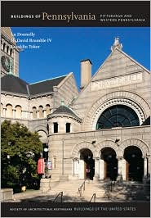
& monasteries to noted landmarks and buildings with exotic histories. Whether you're an architectural buff or a general reader, you will be surprised and amazed by the many captivating buildings built here from the 1790’s to 2010.
The author will have a book signing following her talk.

4

July 2010 Among Friends Volume IV, No. 3
As you should all be aware (you have been reading my articles, right?), the Carnegie Library of Pittsburgh is facing a long-term financial outlook that is very grim. The library and our community are going to have to make some very difficult decisions in the upcoming months about what we love, want, and need most from our libraries. And yes, ultimately, how we’re going to come up with the money to support those things.  Last year the library board created an action plan to address the impending gap between revenue and expenses. That action plan included closing 4 neighborhood locations, reducing hours systemwide (including Sundays at Squirrel Hill), cutting staff, programs, resources, and services. The community’s response to this plan was passionate and vocal in support of the library and against cuts of this magnitude. The financial result of this advocacy was some temporary funding from the City of Pittsburgh (thanks to city council for their support) and some additional long-term funding from a table games tax (thanks to local legislative leadership). This funding has given the library | a little additional time to delay the action plan and come up with long-term solutions - solutions that should be informed and created with and by the community.  In order to gather this input and to engage in the necessary discussions to make these decisions, the library has embarked on a community process. The main part of this process is a series of community meetings and workshops. The 1st set of workshops were held in May. Information was gathered at these workshops and through a survey. The result of that feedback will help guide the next stage.  The next set of meetings will take place July 17-19 (see the Meeting/Venue chart, below). Hopefully one of those dates works for you. I hope to see Friends of the Library represented at every meeting. For more information and to add your voice go to http://www.carnegielibrary.org/future/.  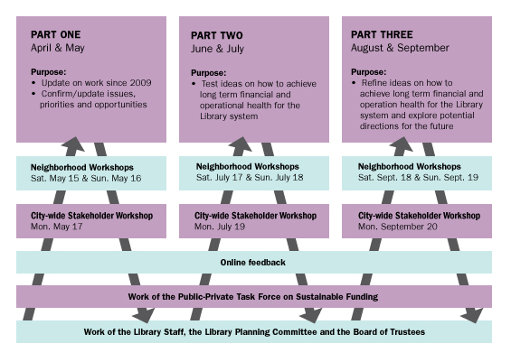
  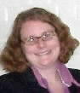 | No Solution without You!  By Holly McCullough, Manager,  Carnegie Library of Pittsburgh –  Squirrel Hill

The Squirrel Hill  Adult Book Discussion Group  meets on Thursday  from 1:00 PM to 2:00 PM  All are Welcome.  July 22  The Outliers by Malcolm Gladwell  August – no meeting  Sept 16  Identical Strangers, A Memoir  of Twins Separated and Reunited  by Elyse Schein and Paula Bernstein, 2007  For him that stealeth a Book from this Library, Let it change into a serpent in his hand and rend him. Let him be struck with Palsy, and all his Members blasted. Let him languish in Pain crying aloud for Mercy and let there be no surcease to his Agony till he sink in Dissolution. Let Bookworms gnaw his Entrails in token of the Worm that dieth not, And when at last he goeth to his final Punishment, let the flames of Hell consume him for ever and aye.  Curse Against Book Stealers, Monastery of San Pedro, Barcelona (no date)  Curse Against Book Stealers, Monastery of San Pedro, Barcelona (no date  Let him be srruck with Palsy, and all his Members blasted.  Let him languish in Pain crying aloud for Mercy and let there be no sur-cease to his Agony till he sink in Dissolution.  Let Bookworms gnaw his Entrails in token of the Worm that dieth not,  And when at last he goeth to his final Punishment, let the flames of Hell consume him for ever and aye.  Curse Against Book Stealers, Monastery of San Pedro, Barcelona (no date)
  Meeting | Venue
  July 17th 10 am.-noon  (Sat.) | Stephen Foster Community Center  286 Main Street  Pittsburgh, PA 15201  (next to the Lawrenceville Library)
  July 17th 2 pm.-4 pm.  (Sat.) | Warrington Recreation Center  329 E. Warrington Avenue  Pittsburgh, PA 15210
  July 18th 2 pm.-4 pm.  (Sun.) | CLP Brookline  708 Brookline Blvd.  Pittsburgh, PA 15226
  July 19th 7:00 pm.- 9:00 pm. (Mon.) | Union Project (Great Hall)  801 N. Negley Avenue  Pgh, PA 15206
5

July 2010 Among Friends Volume IV, No. 3

What is Teen Summer Reading?  Teen Summer Reading (TSR) is a program intended to encourage teens (12 – 18) to read books, magazines, graphic novels, or even web sites during their summer vacation.  How do teens participate?  All aspects of TSR will be managed online at www.carnegielibrary.org/summer/teens. This includes registration, recording items that have been read, and writing reviews (which are optional). Items read may include novels, nonfiction, graphic novels, comic books, magazines, and required school reading. Even materials not belonging to the library count as items read.  There are incentives/prizes!  Books & Book Bags- The Squirrel Hill library will be giving away free books and book bags to teens who register for TSR.  Weekly raffle prize winners will be chosen randomly by computer. Prizes are $10 Target gift cards every week from mid June through mid August. Winners will be contacted by telephone.  One Grand Prize winner will be chosen from all of the CLP registrants. The winner gets SIX tickets to Kennywood and a limo escort!  Teen Fine Forgiveness - We are offering fine forgiveness to teens who register for TSR.  Book Bingo – Teens can play book bingo to be entered into a drawing for an iPod shuffle.  Programs - On June 16th, teens helped decorate the teens area by decorating surfboards. On July 21st from 4-5 we will be having a Speed Book Dating program. Please call 412-422-9650 to register.  Wear a smile and have friends;  wear a scowl and have wrinkles.  George Eliot  1819-1880 |   Art at the Squirrel Hill Library  -  Coming up are:  July: Bob White  pencil drawings  August: The Mainline Group  mixed  September: Christine Hudson  nature  Our schedule is full through December, 2011! If you’d like to exibit after that,  contact Marion Damick,  412-521-3075. | From the desk of Audrey Hines, Senior Librarian  WISE WALK: Summer has  begun and a lot of you have  started to take daily walks around | 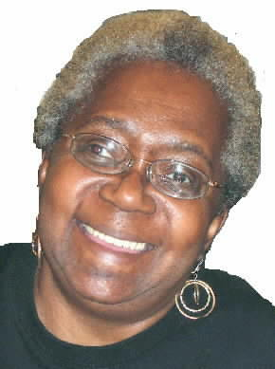
  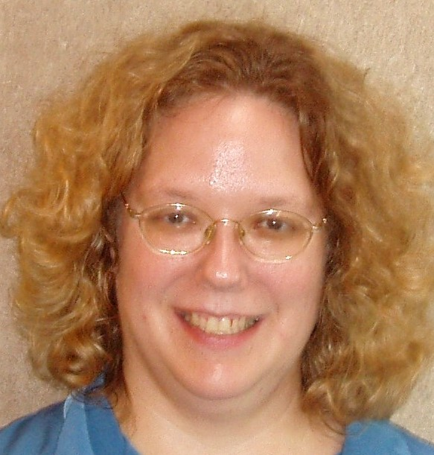 | Are you Ready for Teen  Summer Reading?  by Kim Parker  Teen Librarian
your neighborhoods and parks. At the Carnegie Library of Pittsburgh – Squirrel Hill there is a group of women and men who have started Wise Walk. This group has met every Tuesday since September 2008 at 10:00 am for an hour to walk and encourage each other to keep to the program. AARP states that walking 10,000 steps or five miles daily will keep you in shape; however our goal is to get everyone to walk each and every day, no matter how many steps or how far you go.

So if you want to join our wise walk group, have great conversations, and get a Wise Walk tee shirt and pedometer , meet us at the Library on any Tuesday morning at 10:00 am.

PS : As group leader I have lost 40 pounds,
according to my PCP

BOOK BINGO: Sign up for the Adult Summer Reading program and play BOOK BINGO. There will be a drawing
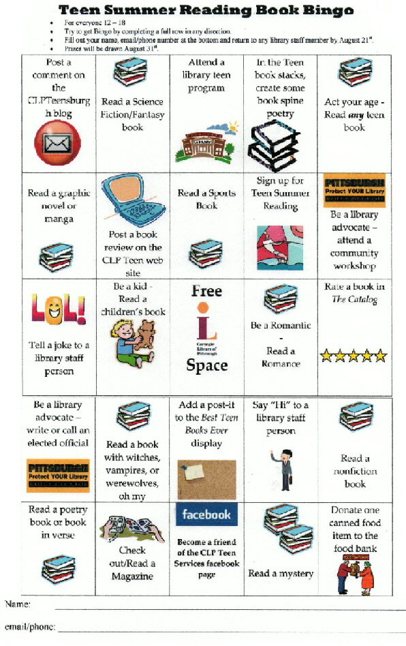

on August 9th for 2 fifty-dollar gift cards. Enter as many times as you like. Get the Bingo sheet at the “ask a librarian” desk. (See the Teen version, left.)
VOLUNTEERS: 
Squirrel Hill Staff and I would like to thank each and every one of our volunteers for the great job they have done, helping us shelve books and audiovisuals, and finding books to be sent to other library locations. How-ever, more volunteers are needed at all locations. If you would like to join the volunteers at Squirrel Hill or any other locations and see what kind of perks we have for adult volunteers, stop and talk to Audrey.
Thank You!

Have a great summer. -- Audrey

NEW MANAGER IN CHILDREN’S DEPARTMENT
When Megan Fogt was hired as a page at the Carnegie Library of Pittsburgh – Squirrel Hill, her interviewers predicted that she wouldn't stay a page for long. Eight years (and a master's degree in Library and Information Science) later, Megan is excited to be the new manager of children's services at Squirrel Hill.

Since Megan has been working in children's services at CLP – Squirrel Hill for five years, she is well known in the community and she is looking forward to managing the fabulous staff and wonderful programs and services at the library.
6

July 2010 Among Friends Volume IV, No. 3

 | Local High School Senior Wins National Contest(s)  “CAPA senior's writing makes her prize-winner” *  Rachel Rothenberg is a senior majoring in literary arts at CAPA 6-12 (the Creative and Performing Arts school). The 18-year-old lives in Squirrel Hill with her parents, Mitchell (a doctor at UPMC/Mercy) and Susan (a candidate for ministry in the Presbyterian church), and her younger brother David. She will attend the College of Wooster in Wooster, Ohio this fall. She seems destined to work her way through college by competing with the brightest and most talented students in the country, and trouncing them thoroughly.
Last year, Rachel won first prize in the Jeopardy! Teen Tournament, $75,000. After splitting 20% between the Greater Pittsburgh Food Bank and her church, (Sixth Presbyterian, at the corner of Forbes and Murray), she will devote most of the money to her college education.

This year, Rachel was one of 15 recipients nationwide of the prestigious Scholastic Art and Writing Awards, winning a gold medal and
a $10,000 scholarship for her portfolio of seven short stories and poems. About 165,000 students submitted entries in fine art, nonfiction,
photography and general writing. Silver medals were awarded to 1,300 students, but only 15 high school seniors won gold medals. They were honored at a ceremony at New York’s Carnegie Hall on June 9.  The Scholastic Arts and Writing Awards were established in 1923 by the Scholastic Publishing Company. The competition has awarded prizes to an illustrious group of students, including cultural and literary icons like Andy Warhol, Truman Capote, Joyce Carol Oates, Sylvia Plath, Robert Redford, Richard Avedon and John Lithgow.  “I don't deserve it,” Rachel said. “I don't think I belong [in that group]. I feel weird comparing my work to other people, let alone icons like Andy Warhol.”  Rachel started writing when she was very young, but she credits her peers and teachers in her writing group at the Creative and Performing Arts school “for helping me become the writer I am.”  In addition to the Scholastic Art and Writing award, Rachel has received recognition for her writing from Princeton University (Milberg Prize) and from Carnegie Mellon University (Martin Luther King, Jr. Creative Writing Awards).  Her favorite authors are Flannery O’Connor, Tony Kushner, and David Sedaris, and she considers their voices important influences on her own work. During a recent interview, Rachel said, “"I'm still undecided on what I want to do in life. Sometimes I think I want to go into teaching and other times, I feel pulled toward social justice work. But whatever it is, I'll always be a writer."  * headline quoted from an article by Karamagi Rujumba in the PittsburghPost-Gazette of Monday, April 19, 2010. We relied heavily on that article in writing this one. Read more at: http://www.post-gazette.com/pg/10109/1051537-298.stm#ixzz0pdIYnTW5  A Scholastic site has all 15 winning portfolios: http://artandwriting.org/ORGGalleries.  More info about the Jeopardy! win: www.post-gazette.com/pg/09318/1013420- 67.stm |  | Before her current internship in the office of Pittsburgh City Councilman Bruce Kraus, Ms. Rothenberg interned at the Andy Warhol Museum, an  experience that was the basis of her poem "Eulogy for Andy," which was part of her portfolio.  Eulogy for Andy  Rachel Rothenberg  “I had to do it,” she said.  “He had too much control over my life.”  But even that couldn’t kill you, fingering your battle wounds,  art for art’s sake.  Not even the women who floated through your silver rooms,  lovely and quiet as breath on the back of your neck,  who faded into nothingness and black-and-white and it was all your fault  could do it.  What got you,  finally,  was your own fear  of fear.  You were your world’s own negative,  sad and smoky with the Slavic dreariness of everyone who breathes  the air of this last coal town.  We examine your pictures, your photographs,  the giant women in red lipstick,  plastic clouds,  the sting of our own  mortality. In this picture,  between the red-yellow lights of your fame,  you’re standing with the children  drunk on their own desire, but you say nothing.  In another, we see the screen goddess,  her eyes glazed over, frozen by your hand,  and she's telling us that you have left the building.  We walk to Mass hand-in-hand,  light candles for you, whisper your name in a language  no one speaks anymore over and over, believing  in God and Mary and the saints and your hot-pink ghost rapturing us body and soul into Times Square.  Half-lit in the smoke we see you as you were  in life, pale and silvermoon and yet,  so much brighter.
  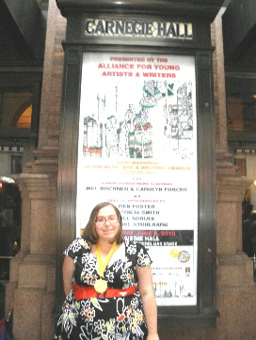 | 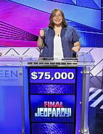  Rachel attends the Pittsburgh High School for the Creative and Performing Arts. In September 2003 the Pittsburgh public school system opened a new building in the Cultural District at Ninth Street and Fort Duquesne Blvd. in downtown Pittsburgh. The building is a world-class facility that includes a 400-seat auditorium, a black box theatre, an art gallery, media arts center, fitness center, computer labs and rehearsal spaces for all departments. Students are invited from Allegheny County and across the state of Pennsylvania to attend Pittsburgh CAPA. CAPA has 500+ full time students.  7

CARNEGIE LIBRARY OF  PITTSBURGH -- SQUIRREL HILL 5801 Forbes Avenue  Pittsburgh, PA 15217  Adult Services: 412-422-9650  Children's Services: 412-422-9841  Fax: 412-422-5811  www.carnegielibrary.org/clp/sq  Is your Friends Membership up to date? Please check your mailing label/membership card. ➔  If the date is before 07/10, you need to renew. Mail us the form below.  DESPERATELY NEED: empty copy-paper boxes – for 10 reams of 8 ½ x 11 paper – with lids. Also need EPSON ink cartridges, whether full or empty – T0601-T0604 and T0691-T0694. Leave at desk for Friends. | ADDRESS SERVICE REQUESTED  your donation is tax deductible as a charitable contribution | 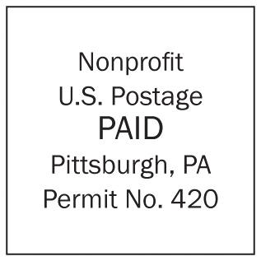
  
  «exptext»  «expdate»  EXPIRES:  MONTH YYYY | «first» «last»  «addr»  Pittsburgh, PA «zip» «zip2» NAME  ADDRESS  CITY, ST
A door is what a dog is  always on the wrong side of.  Ogden Nash |  | Nobody minds having what is too good for them  Jane Austin
July 2010 Among Friends Volume IV, No. 3

make checks payable to:  Friends of the Squirrel Hill Library  and mail to:  Margie Spenser  5900 Douglas St  Pittsburgh, PA 15217  Check one box:  New Member Renewal  Check one OR two boxes:  $5.00 $10.00 $15.00  $25.00 Other___ DONOR (free  for first year)  Name: _____________________________________  ^{(Last)} ^{(First)}  Address: ___________________________________  City/State: ___________________Zip: ___________  Phone(s): ___________________Date: ___________  E-mail address: ______________________________  Please check all activities you can help with:  Periodic Book Sales Sorting Used Books  Adopt-a-Shelf Program Gardening  Library Advocacy Newsletter/ Mailings  (lobbying, writing letters)  COMMENTS_________________________ | 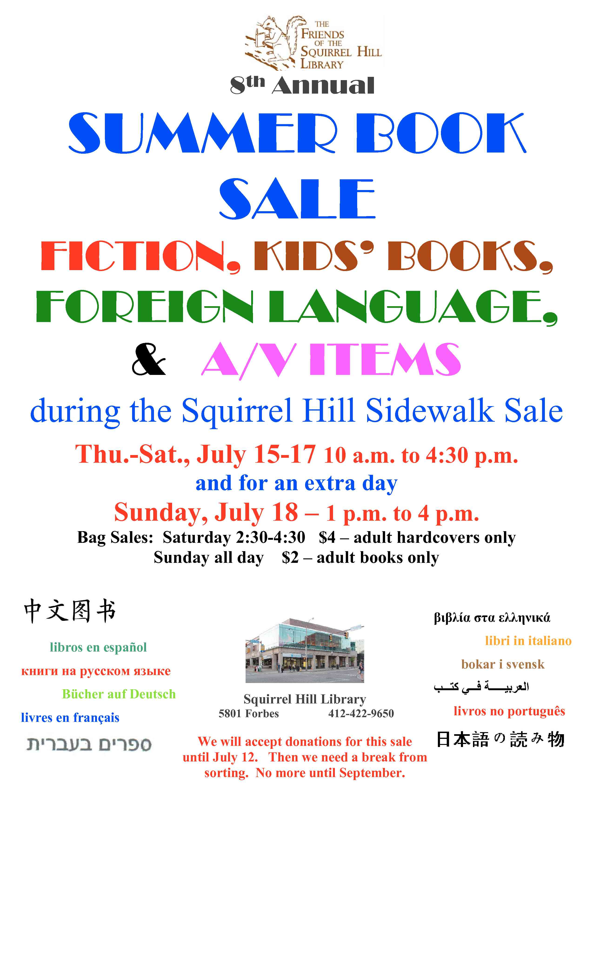  8  WANTED TO BUY: DVD of  “A Thousand Clowns” starring  Jason Robards and Barbara  Harris. stan5600@verizon.net |   Friends Officers  Joan Schwartzman President  Marion Damick Vice President  Eleanor Hershberg Treasurer  Margie Spenser Secretary  write us at friends@pittsburghusedbooks.comm

